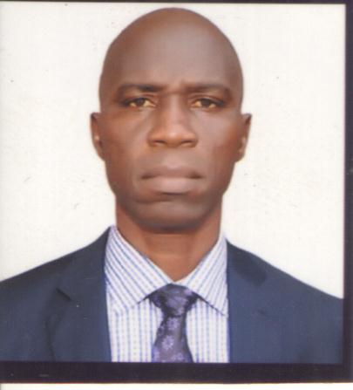

IDOWU, Olusoji Gabriel

HND Acct, B.sc Acct

TAXATION

[Idowugold2012@gmail.com](mailto:Idowugold2012@gmail.com)

0803-471-0021, 0909-057-6667

ASSISTANT LECTURER

ACCOUNTING

TAXATION

CIBN (Student Membership)

ICAN (Student Membership)

Institute of Policy Management Development (Fellow)

B.sc Project: Cooperate Social Responsibility (Study of Shell Petroleum Development Corporation)

**WORK EXPERIENCE:**

* **Oppresso** **Petroleum**

Depot Manager 2014- 2016

* **African Petroleum PLC**

Oko-Eiye Service Station (Product procurement Officer) 1996-2014

* **Wema Bank PLC**

Idiroko Branch (Assistant Manager) 1992-1995

AjileteEgbado Branch (Branch Supervisor) 1986-1992

OwodeEgbado Branch (Clerical Officer) 1984-1986

**PUBLISHED PAPER**

Adelusi, A. I & Idowu, G.O. (2018) “Evaluation of government revenue on economic growth in Nigeria (2007-2017)”, *International Journal of Scientific Research in Social Science and Management Studies,* 3(3) 63-78

**CONFERENCES ATTENDED AND PAPER PRESENTED:**

1. Idowu, O.G (2019): Tax policies and entrepreneurship development in Nigeria   
   (study of Ogun State, South West, Nigeria). A conference paper presented at the 10th school of management studies National conference from 26th -29th August, 2019.
2. Idowu, O.G (2018): Tax justice and performance of small and medium scale enterprises in Ogun state. A conference paper presented at the 1st international conference and exhibition on technological innovation and global competitiveness from 5th- 8th November 2018.
3. Idowu, O.G (2018): Evaluation of government revenue on economic growth. 1st International conference of Federal Polytechnic, Ilaro, Annual National Conference from 5th-8th of November 2018.
4. Idowu, O.G (2017): Effect of Non-remittance of Internally Generated Revenue (IGR) on Ogun West Senatorial District. A conference paper presented at the school of management studies, Federal Polytechnic, Ilaro, Annual National Conference from November 28-30th 2017.
5. Idowu, O.G and Jimoh Ibrahim (2016): Consumer’s satisfaction in Banking and Service. A conference paper presented at the 6th Annual Academic Conference of Academic Staff Union of Polytechnics ASUP Ilaro chapter 2016.
6. Idowu, O.G (2016): The impact of consumer service on customer detention in Nigerian banking industry. 5th ASUP national conference from 16th- 19th October, 2016.

**SEMINAR AND WORKSHOP**

1. Ogun State Ministry of Community Development and Cooperatives. (Managing cooperative societies for efficient service delivery & sustainability. August, 2019).
2. The Federal Polytechnic, Ilaro, Ogun State. A1- Day in house training for newly recruited staff held on 27th, March, 2019.
3. Digital Bridge Institute. Training programme for staff held at ICT Center the Federal Polytechnic, Ilaro, from 10th - 14th Dec, 2018.
4. Design + Leadership in the 21st century. A multidisciplinary seminar for staff and students in higher institutions. Held at The Federal polytechnic, Ilaro. June 18, 2018.
5. Ministry of Community Development and cooperatives. Cooperative Movement and Stakeholders. (Inclusion: Strategy for cooperative economic revitalization) held in November - December, 2017.
6. Ogun State ministry of community development and cooperatives (The place of cooperative organization in a depressed economy), held in October - November, 2016.

**CURRENT ACADEMIC RESPONSIBILITIES:**

1. Taxation Department’s Examination Officer
2. Taxation Department’s Welfare Officer
3. Member NAMAS Advisory Committee
4. Member Taxation Department Accreditation Committee

**COMPUTER KNOWLEDGE:**

* Microsoft Word and Microsoft Excel

**HOBBIES:**

Reading good books, Travelling, Computer Analysis, Impacting Knowledge and meeting people.